Answer to the Question Number 2: (Conceptual Questions)
1. Collision Resolution in Hash Tables: Scenario of Clustering with Linear Probing: When using linear probing for collision resolution, if multiple entries hash to the same index and subsequent entries are placed in consecutive slots, it can create a "cluster" of occupied slots. For instance, if three entries hash to the same index, for instance, index 2, and they are inserted one after another, the entries will occupy indexes 2, 3, and 4, leading to a cluster.
Impact on Performance:
Insertion Operations: As more entries are added, the likelihood of hitting a cluster increases, which means that subsequent insertions may require more probes, leading to longer search times.
Search Operations: Searching for an entry also becomes inefficient as the probe sequence may have to skip over several occupied indices within a cluster before finding the desired value or confirming it's not there.
Alternative Strategies to Mitigate Clustering:
Quadratic Probing: Instead of looking at the next immediate index, quadratic probing checks farther indexes based on a quadratic function, potentially reducing clustering.
Double Hashing: Uses a second hash function to calculate the probe step size, which can help in distributing entries more uniformly.
Dynamic Hashing: Adjusts the size of the hash table and rehashes the entries when a certain load factor is reached, thereby minimizing clustering.

2. Patient Prioritization Mechanism
Prioritization Based on Severity: The HospitalLinkedList class prioritizes patients by adding them in a way that respects their severity level. When adding a patient, the insertion logic navigates through the linked list and places the new patient node based on comparisons with existing nodes. Higher severity patients (i.e., "high") are inserted before lower severity patients ("moderate" and "low"), ensuring that they are treated first.
Modifications for Changing Severity: If a patient's severity changes during their stay, the current approach requires the patient to be removed and then reinserted to maintain the priority order. This would involve:
  - Removing the patient node from the linked list.
  - Inserting the patient back in the correct position based on the updated severity level.
3. Binary Search Tree Balancing
Efficiency with Ascending Order Additions: If properties are added in ascending order of their IDs, the PropertyBST would degenerate into a linked list-like structure where each node has only a right child, resulting in inefficient operations. The time complexity for insertion, deletion, and search operations would increase from O(log n) to O(n), making the structure less efficient.
Balancing Techniques: AVL Trees: Self-balancing BSTs that maintain balance through rotations after insertions and deletions, ensuring that the height of left and right subtrees of any node differ by at most one.
Pros: Always guarantees O(log n) time complexity for operations.
Cons: More complex to implement due to the need for balancing after updates.
Red-Black Trees: Another type of self-balancing BST that allows for less rigid balancing rules than AVL trees but still maintains overall efficiency.
Pros: Less rigid balancing means faster insertions and deletions compared to AVL trees.
Cons: More complex than basic BSTs to implement and understand.

4. Dynamic Memory Management in Linked Lists
Efficient Memory Management: In the HospitalLinkedList class, efficient memory management is achieved by dynamically allocating memory for each node and the Patient object within it. When a patient is removed, the corresponding memory for that node is deallocated to prevent memory leaks.
Handling Memory Allocation Failures: If memory allocation fails (for example, if new returns a null pointer), it is crucial to handle the situationcorrectly. In C++:
- We should check if the allocation was successful (ensure the pointer is not null).
- If it fails, we could display a warning message or throw an exception to avoid proceeding with invalid pointers. Such as -
Patient* newPatient = new Patient(...);
if (!newPatient) {
cout << "Memory allocation failed!" << endl;
return; // Or throw an exception
}
5. Rehashing in Hash Tables
When Rehashing Becomes Necessary: In the BookingHashTable class, rehashing becomes necessary when the load factor (the ratio of the number of entries to the table size) exceeds a certain threshold, commonly set around 0.7. This threshold indicates that the hash table is getting close to full capacity, which can lead to increased collisions and decreased performance for insertion and search operations. For example, if the current size of the hash table is 15 and the number of entries reaches 11 (making the load factor approximately 11/15 ≈ 0.73), it is time to trigger a rehash. When this condition is met, we would:
Resize the Hash Table: Typically, the new size is chosen to be double the current size, although it can also be another prime number to help with better distribution and reducing collisions.
Create a New Hash Table: Allocate memory for the new hash table with the increased size.
Data Consistency During Rehashing: To ensure data consistency during rehashing, the following steps should be taken:
Store Existing Entries: While resizing, all existing entries need to be temporarily stored to facilitate their re-insertion into the new hash table.
Rehash and Insert: Once the new table is created, loop through each entry from the old table and use the hash function to insert them into the new hash table. This insertion should follow the same collision resolution strategy (e.g., linear probing) as the original table to maintain the correct order and positioning.
Update the Reference: Finally, replace the old hash table reference with the new hash table reference in the BookingHashTable class.
Delete Old Table: Free the memory allocated for the old hash table to prevent memory leaks.
Rehashing is a vital process in maintaining the performance of hash tables by resizing and redistributing entries when the load factor exceeds a certain limiting threshold.

Answer to The Question Number 3: (UML Diagram)
- Here is the Booking Class Diagram –
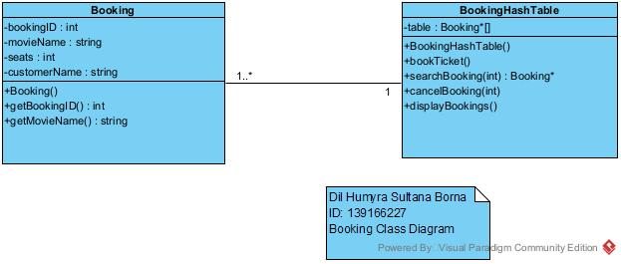

- Here is the Hospital Class Diagram –

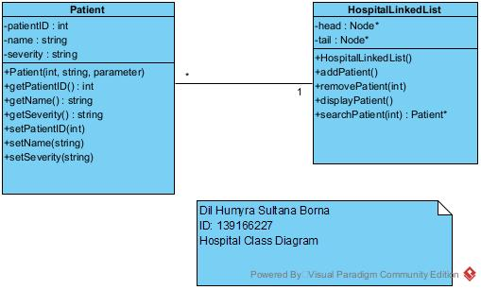

- Here is the Property Class Diagram –

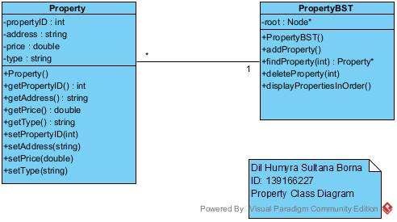

Answer to The Question Number 4: (Output Screenshot)

- Here are the Movie Ticket Booking System output screenshots –

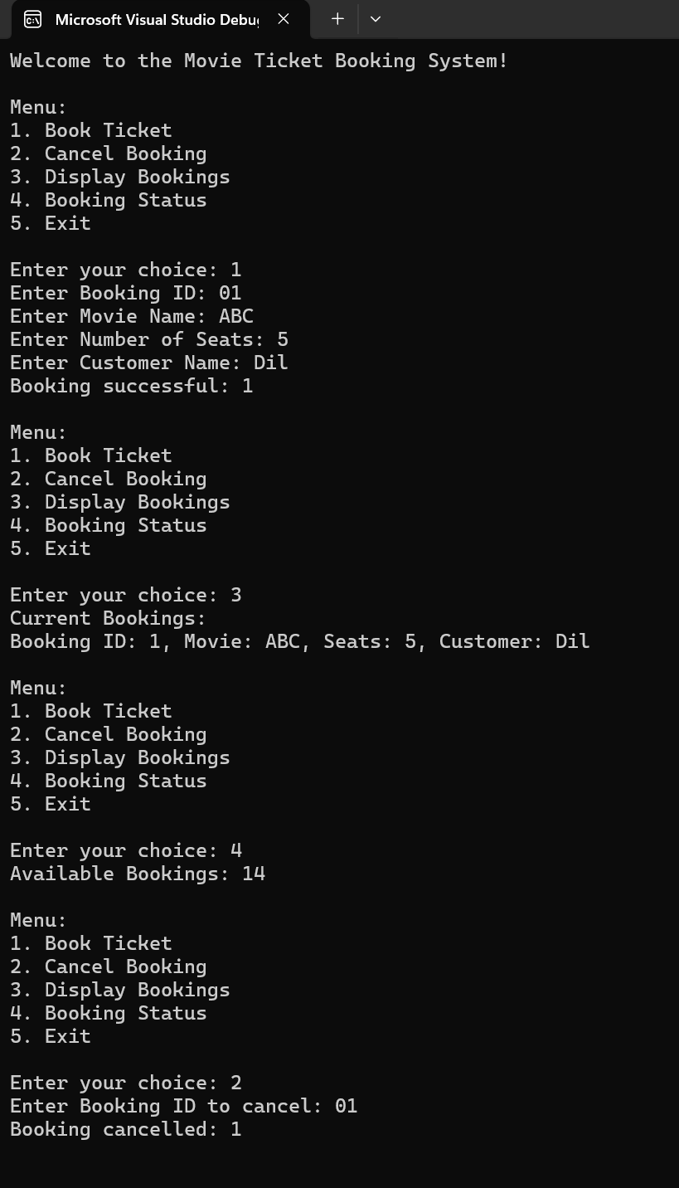
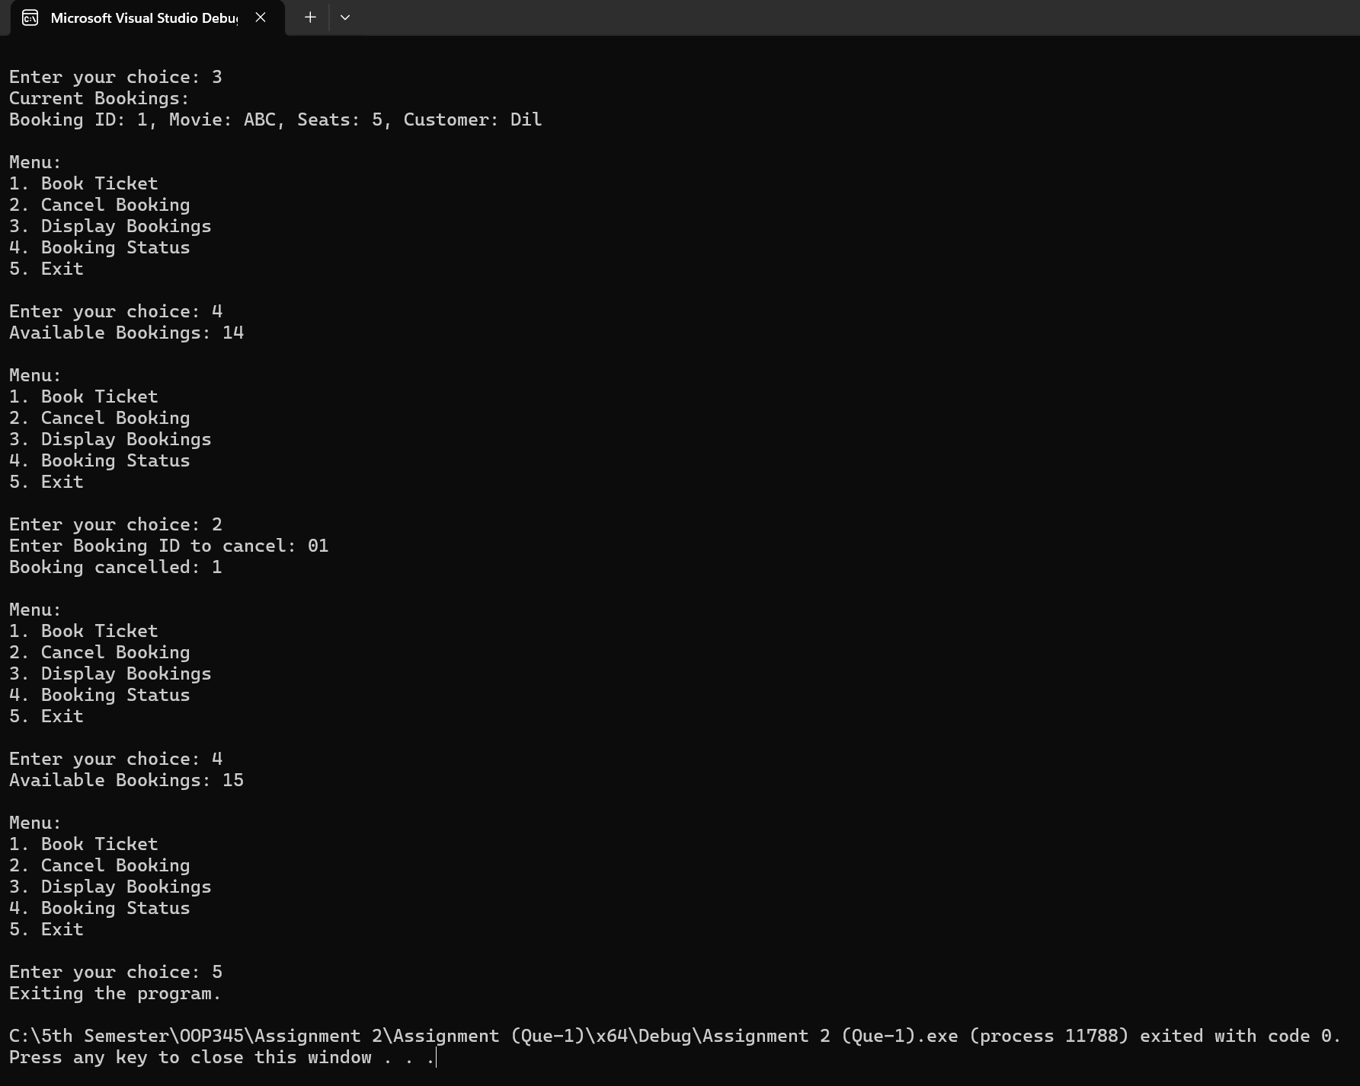

- Here are the Emergency Hospital Management System output screenshots –
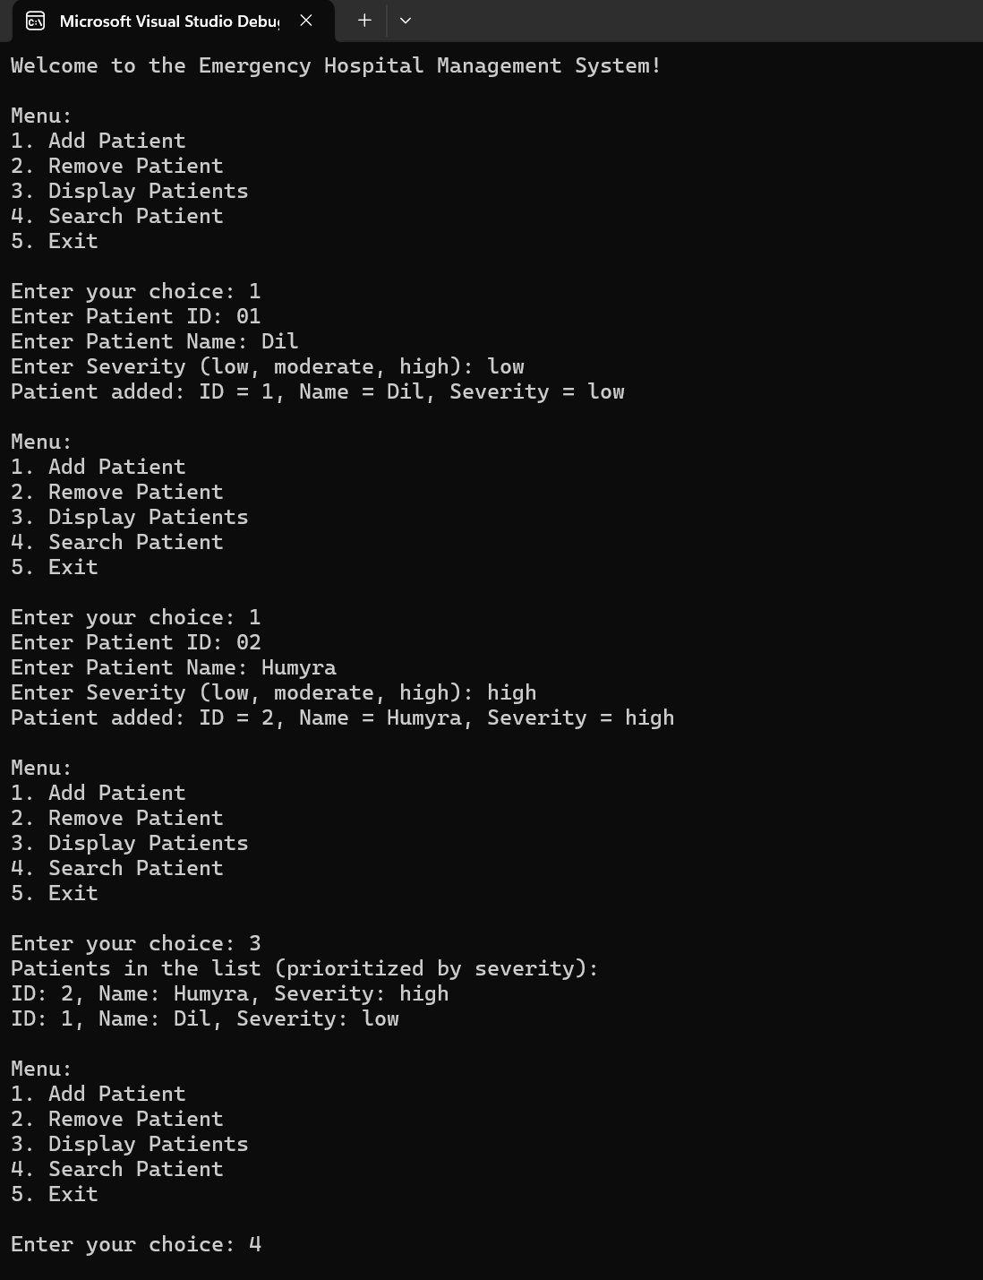

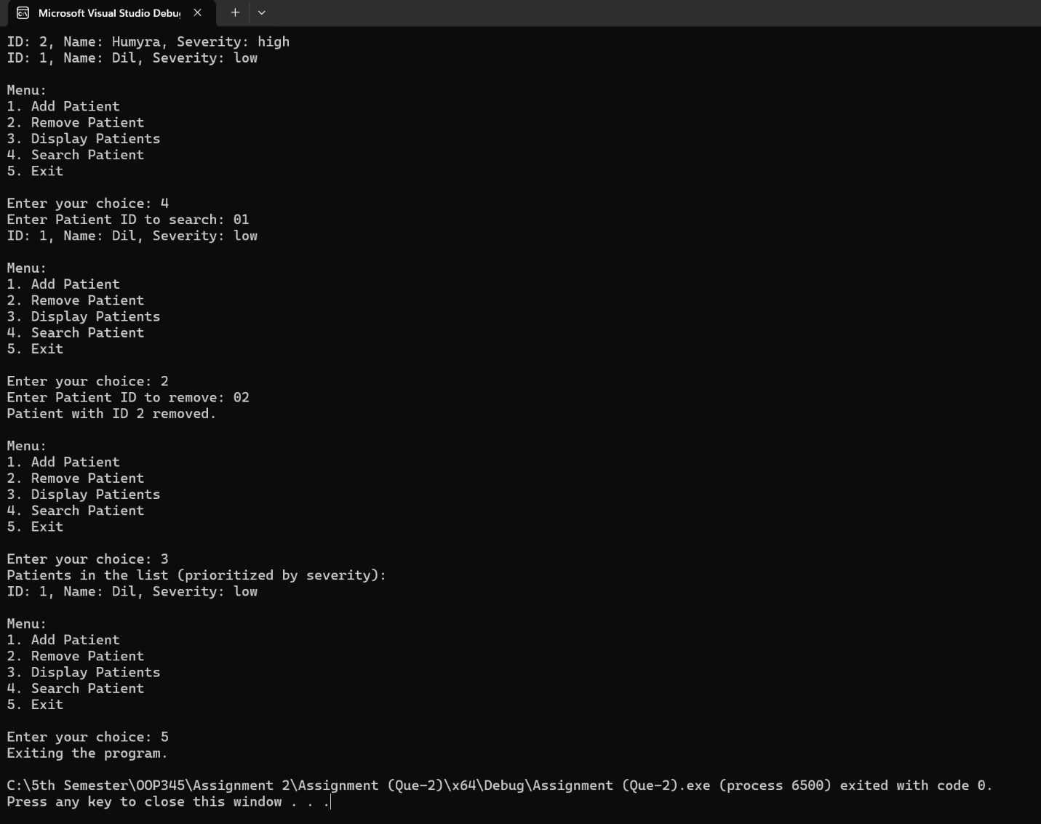

- Here are the Real Estate Property Listings output screenshots –

